**EXPERIMENT NO 10**

~ ARYA RAUL

COMPS 20

**Experiment No. 10: Binary Search Method**

**Aim :** **Implementation of Binary Search Method**

**Objective:** 1) Understand how to implement Binary Search algorithm.

**Theory:**

The improvement to searching method to reduce the amount of work can be done using binary searching. Binary searching is more efficient than linear searching if an array to be searched is in sorted manner.

Here an key item to be searched is compared with the item at middle of array. If they are equal search is completed. If the middle element is greater than key item searching proceeds with left sub array. Similarly, if middle element is less than key item than searching proceeds with right sub array and so on till the element is found.

For large arrays, this method is superior to sequential searching.

**Algorithm**

FIND(arr, x,  first,  last)

   if (first > last)then

      return -1

   End if

   mid = (first + last) / 2

   if (arr[mid] = x)

      return mid

   End if

   if (arr[mid] < x)

      return find(arr, x, mid+1, last)

   End if

   return find(arr, x, first, mid-1)

**Code:**

#include <stdio.h>

#include <stdlib.h>

struct node {

int data;

struct node *leftChild, *rightChild;

};

struct node *root = NULL;

struct node *newNode(int item){

struct node *temp = (struct node *)malloc(sizeof(struct node));

temp->data = item;

temp->leftChild = temp->rightChild = NULL;

return temp;

}

void insert(int data){

struct node *tempNode = (struct node*) malloc(sizeof(struct node));

struct node *current;

struct node *parent;

tempNode->data = data;

tempNode->leftChild = NULL;

tempNode->rightChild = NULL;

//if tree is empty

if(root == NULL) {

root = tempNode;

} else {

current = root;

parent = NULL;

while(1) {

parent = current;

//go to left of the tree

if(data < parent->data) {

current = current->leftChild;

//insert to the left

if(current == NULL) {

parent->leftChild = tempNode;

return;

}

}//go to right of the tree

else {

current = current->rightChild;

//insert to the right

if(current == NULL) {

parent->rightChild = tempNode;

return;

}

}

}

}

}

struct node* search(int data){

struct node *current = root;

printf("\nVisiting elements: ");

while(current->data != data) {

if(current != NULL) {

printf("%d ",current->data);

//go to left tree

if(current->data > data) {

current = current->leftChild;

}//else go to right tree

else {

current = current->rightChild;

}

//not found

if(current == NULL) {

return NULL;

}

}

}

return current;

}

void printTree(struct node* Node){

if(Node == NULL)

return;

printTree(Node->leftChild);

printf(" --%d", Node->data);

printTree(Node->rightChild);

}

int main(){

insert(10);

insert(14);

insert(19);

insert(26);

insert(27);

insert(31);

insert(33);

insert(35);

insert(42);

insert(44);

printf("Insertion done\n");

printTree(root);

struct node* k;

k = search(35);

if(k != NULL)

printf("\nElement %d found", k->data);

else

printf("\nElement not found");

return 0;

}

**Output:**

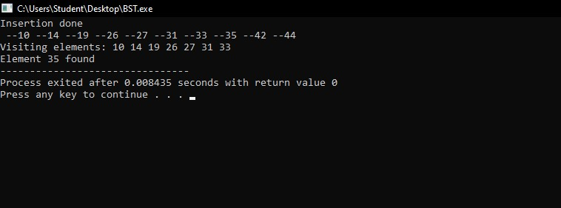

**Conclusion:**

implementing the Binary Search method offers an efficient way to find items in sorted data with a logarithmic time complexity. It's versatile and straightforward to implement but requires sorted data and may not be suitable for unsorted or frequently changing datasets.